GroundcrewAI Stage 4.2

- Go back to agent and go to your “Upload Headshot” Topic

- Click the “+” button below the question node and “Add a tool > Upload Headshot” flow that you just created
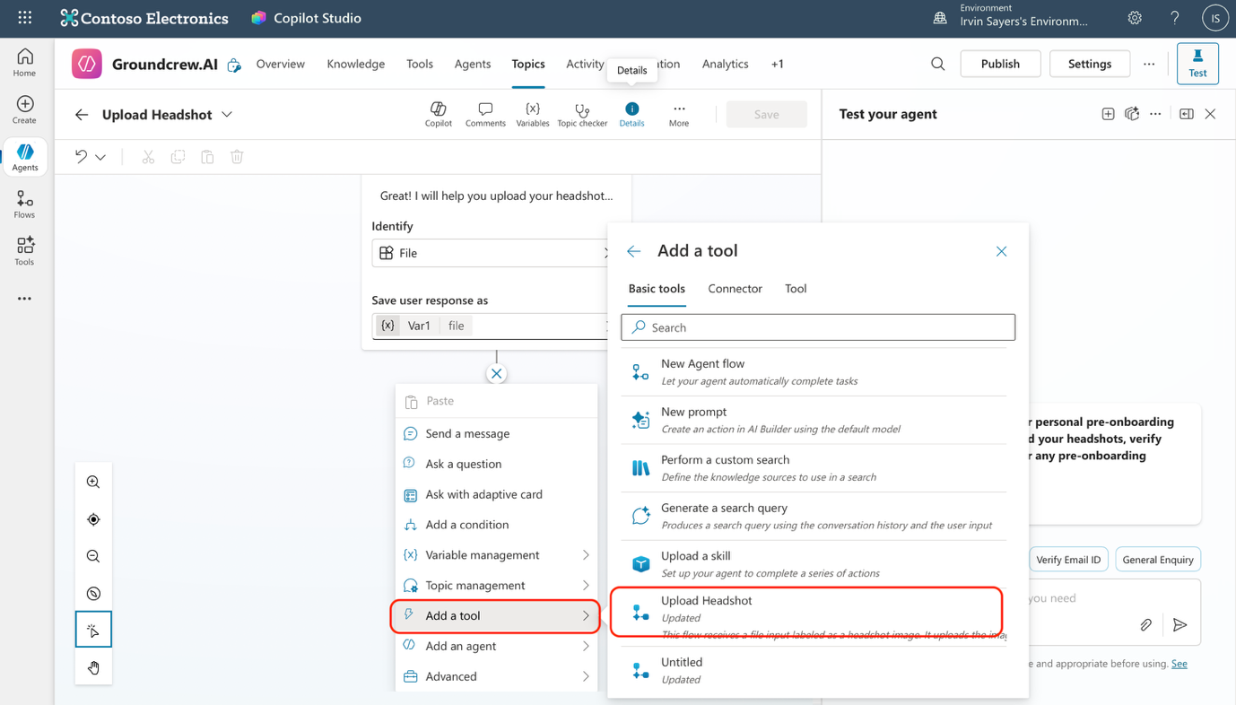

- In the input section, paste this formula.
“{ contentBytes: First(System.Activity.Attachments).Content, name: First(System.Activity.Attachments).Name }”

- Click the “+” button below the “Action” node and add a “Message node” Add the “Uploaded” variable to the message.
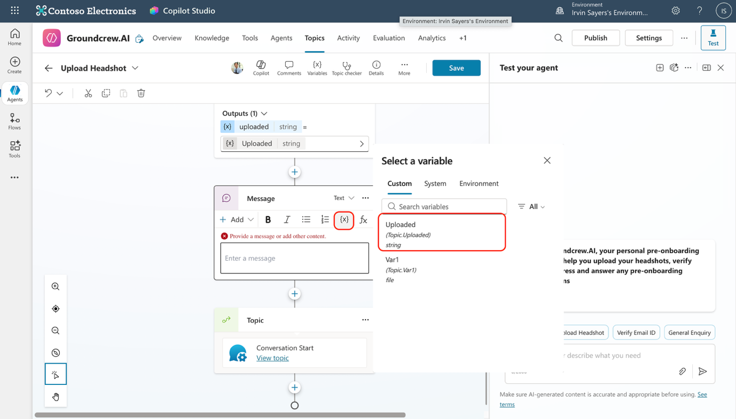

- Add another node below the “Messages” node “Topic management > Conversation Start” and click save

- Lastly, under “conversation start” Topic, go to the condition node that says “Var1 is equal to Upload Headshot” and add a node “Topic management > Upload Headshot”. Your end result should like the image below
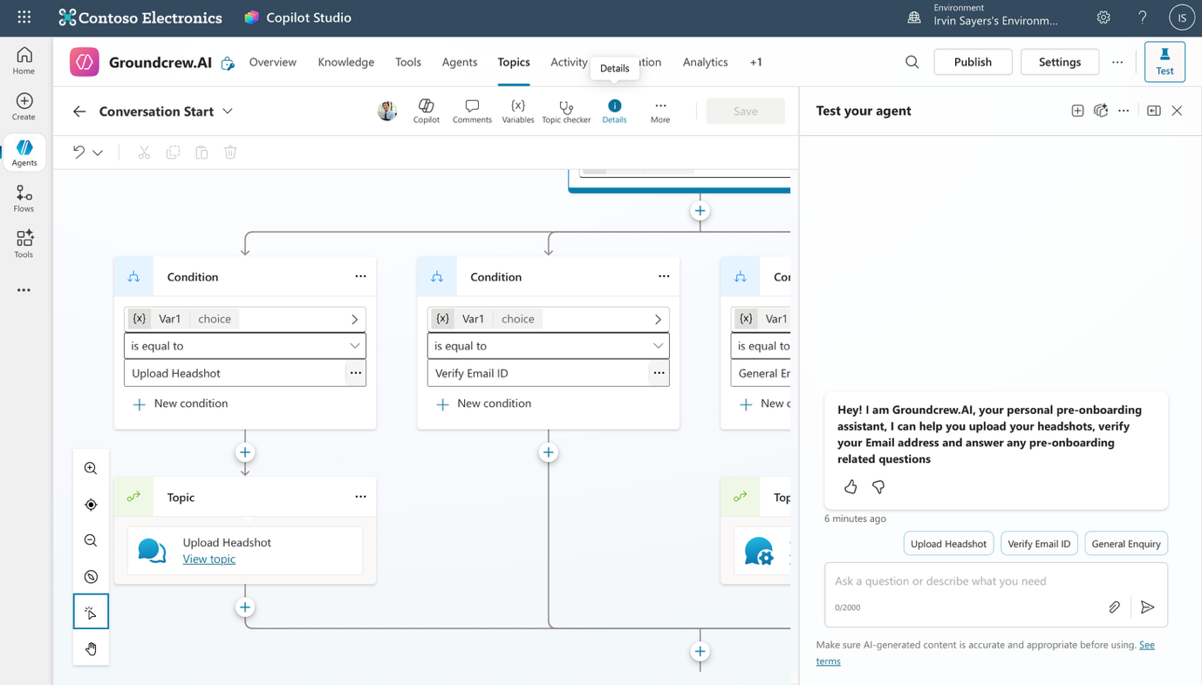

- Congratulation you have now created a bot that allows you to enquire about day 1 tasks and upload your headshot to the Dataverse table! Great going. If you are comfortable try out the bonus steps, or move to testing your agents current capabilities!

